Basic Configuration of Modules
All of the products available to purchase are OpenSource and we are trying to build a community that add functionality and help develop this software further.
This document gives an outline of how-to setup and prepare firmware for uploading. The latest functionality is always available on GitHub.
This document allows people to upload the latest firmware or compile their own!

Contents
Basic Configuration of Modules 1
Download Arduino IDE 3
Installing Boards 4
Setup Boards 5
ESP32 5
Teensy 6
Downloading Libraries 7
Configuring Firmwares 8
Basic Setup 8
Can2Cluster 9
Editing Firmware 10
Uploading Firmware 11
Prepare the Board 11
Upload the Code 12

Download Arduino IDE
Use the link below to download and install Arduino IDE:
https://www.arduino.cc/en/software

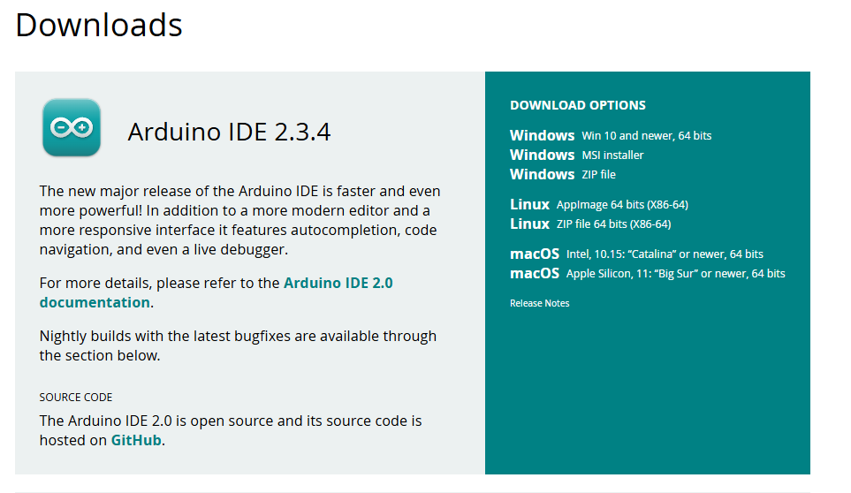

Installing Boards
Once installed, add the boards (ESP32 & Teensy). Go to ‘File’, ‘Preferences’:
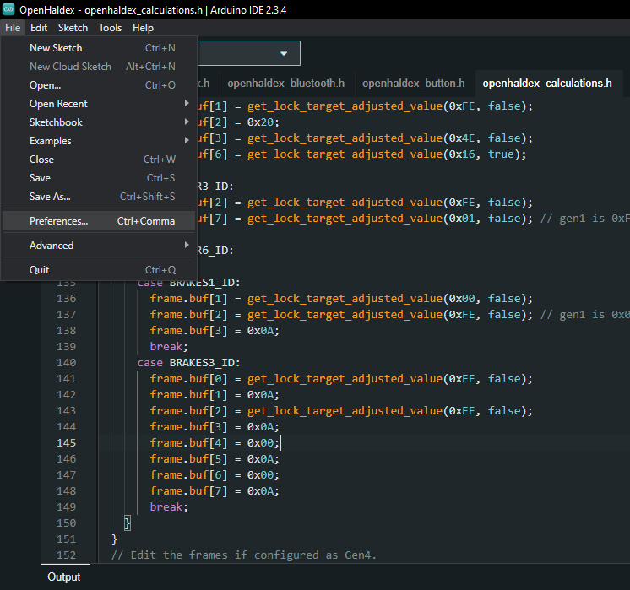
Click on ‘Additional Boards Manager’:
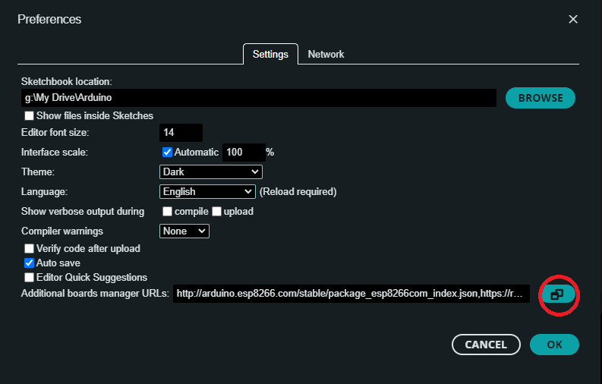
And copy/paste the below. One line per item:
http://arduino.esp8266.com/stable/package_esp8266com_index.json
https://raw.githubusercontent.com/espressif/arduino-esp32/gh-pages/package_esp32_index.json
https://www.pjrc.com/teensy/package_teensy_index.json

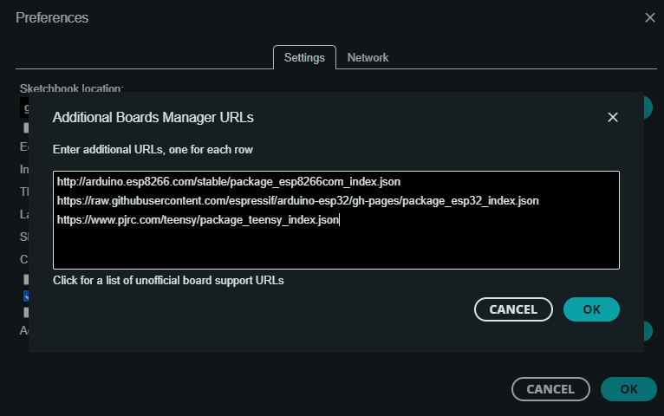

Setup Boards

ESP32
Install ESP32 boards by searching and installing. Downgrade to V2.0.18 (the latest version has known board issues!). Use the drop-down to choose a version.
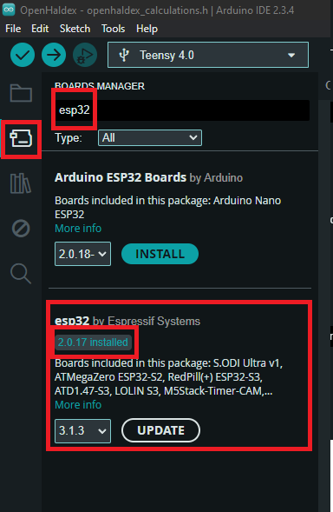

Teensy
Similarly, if you’re editing or updating code for OpenHaldex, you can also install the Teensy boards. Search for Teensy and install:
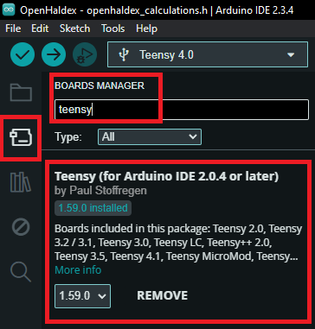

Downloading Libraries
To avoid confusion and to speed up compiling, it’s recommended to use the same libraries.
Download the libraries from:
https://github.com/adamforbes92/arduinoLibs
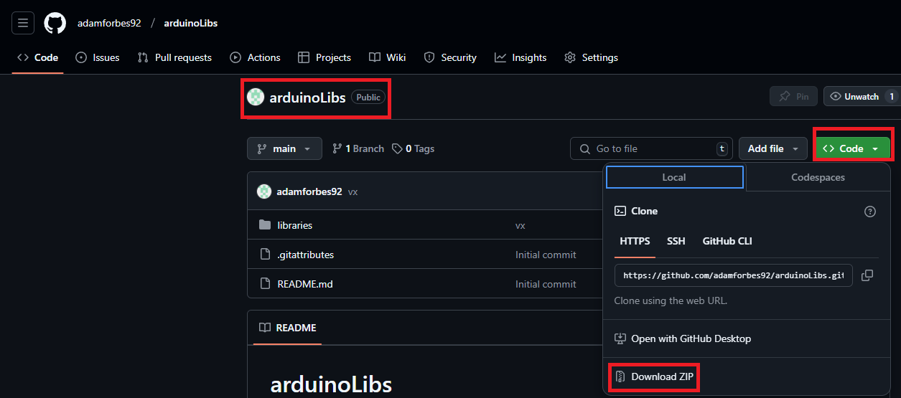
Extract these to your Arduino folder which you can find the location of in Preferences:
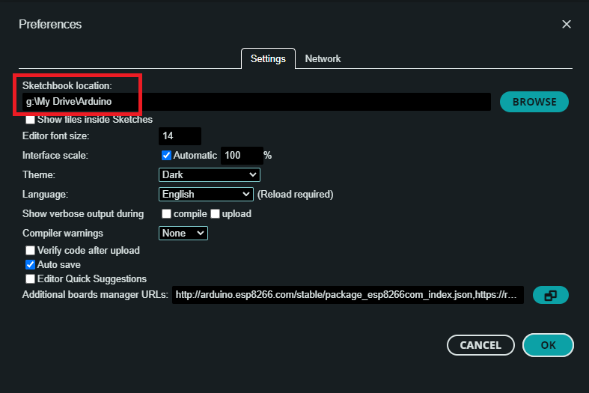
You should now have all the libraries installed:
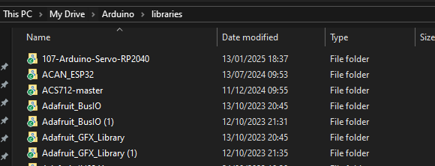

Configuring Firmwares
The process for each device is similar – SpeedPulser, Can2Cluster, FISCuntrol, MFSWController all use ESP32. OpenHaldex uses the Teensy 4.0 board.

Basic Setup
All of the firmwares are built using similar methodology so that revising functions are easy. The main variables for editing are stored always stored in ‘_defs.ino’ and are fully commented to give understanding of what the changes do.

Can2Cluster
Download the most recent firmware from:
https://github.com/adamforbes92/canbus2cluster

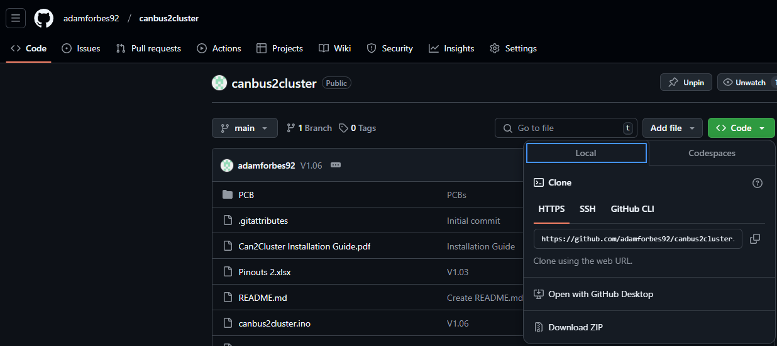
Extract these files to your Arduino directory in their own folder. These are not in the ‘Library’ folder!
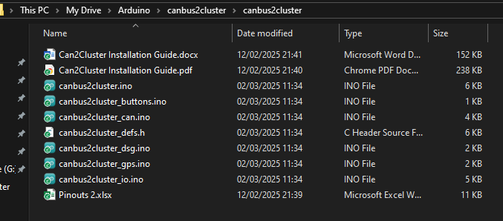

Editing Firmware
The main variables are stored within ‘_defs.ino’:
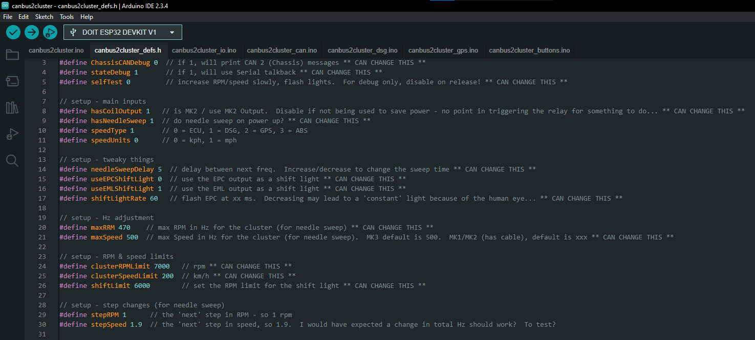
So for example, if you would like the needle sweep faster, decrease ‘needleSweepDelay’. If you would like to use the EPC output as a shift light instead of EML, change EPC to 1 and EML to 0.

Uploading Firmware

Prepare the Board
Once you’re happy that you’ve setup the firmware to how you’d like it, it can be uploaded. Connect the device (either ESP32 or Teensy) to the computer.
In Arduino, click ‘Tools’, ‘Port’ and choose the relevant port for the ESP32. If you only have one selected, there should only be one available:
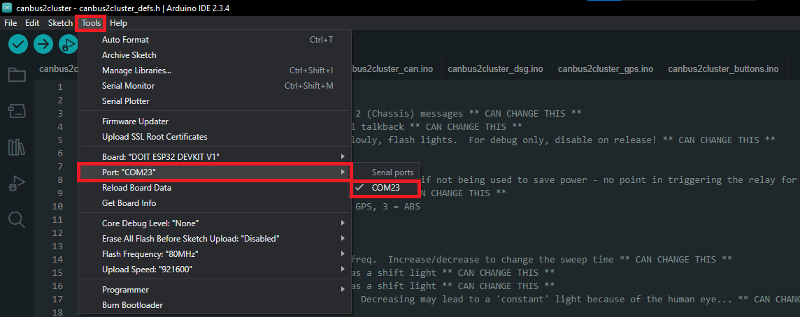

It may be necessary to choose the correct ESP32 Board (ESP32 Devkit V1):
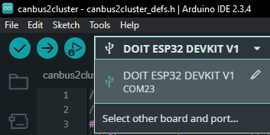
If unavailable, choose ‘Select other Board and Port’ and search:
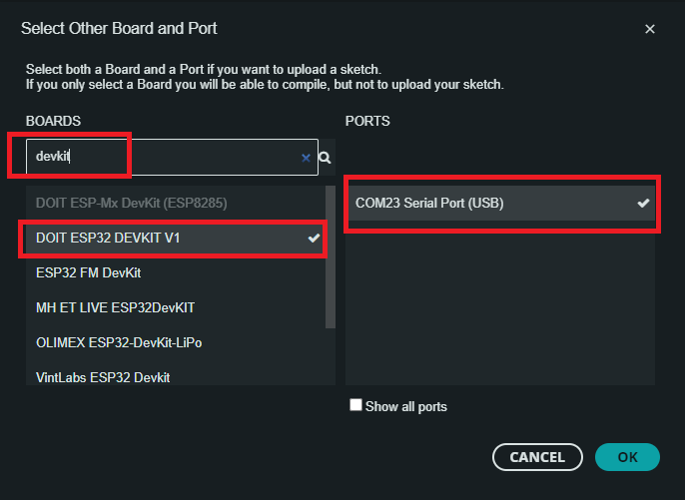

Upload the Code
The final part, upload the code! Choose the > arrow:
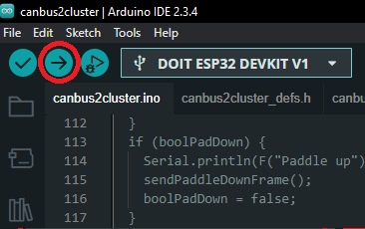
The code will compile and will be loaded to the ESP.

